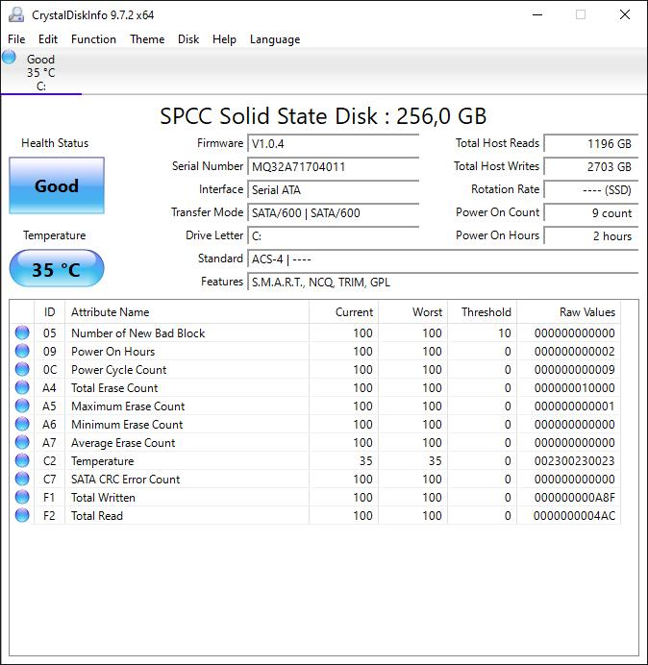
My SP A55 SSD shows me a S/N starting with WWDD24121… and the firmware version HDFED1.2 This is a totally different format of version. Is this right?
The tool for check/update the firmware didn’t work, because the tool didn’t find a server.
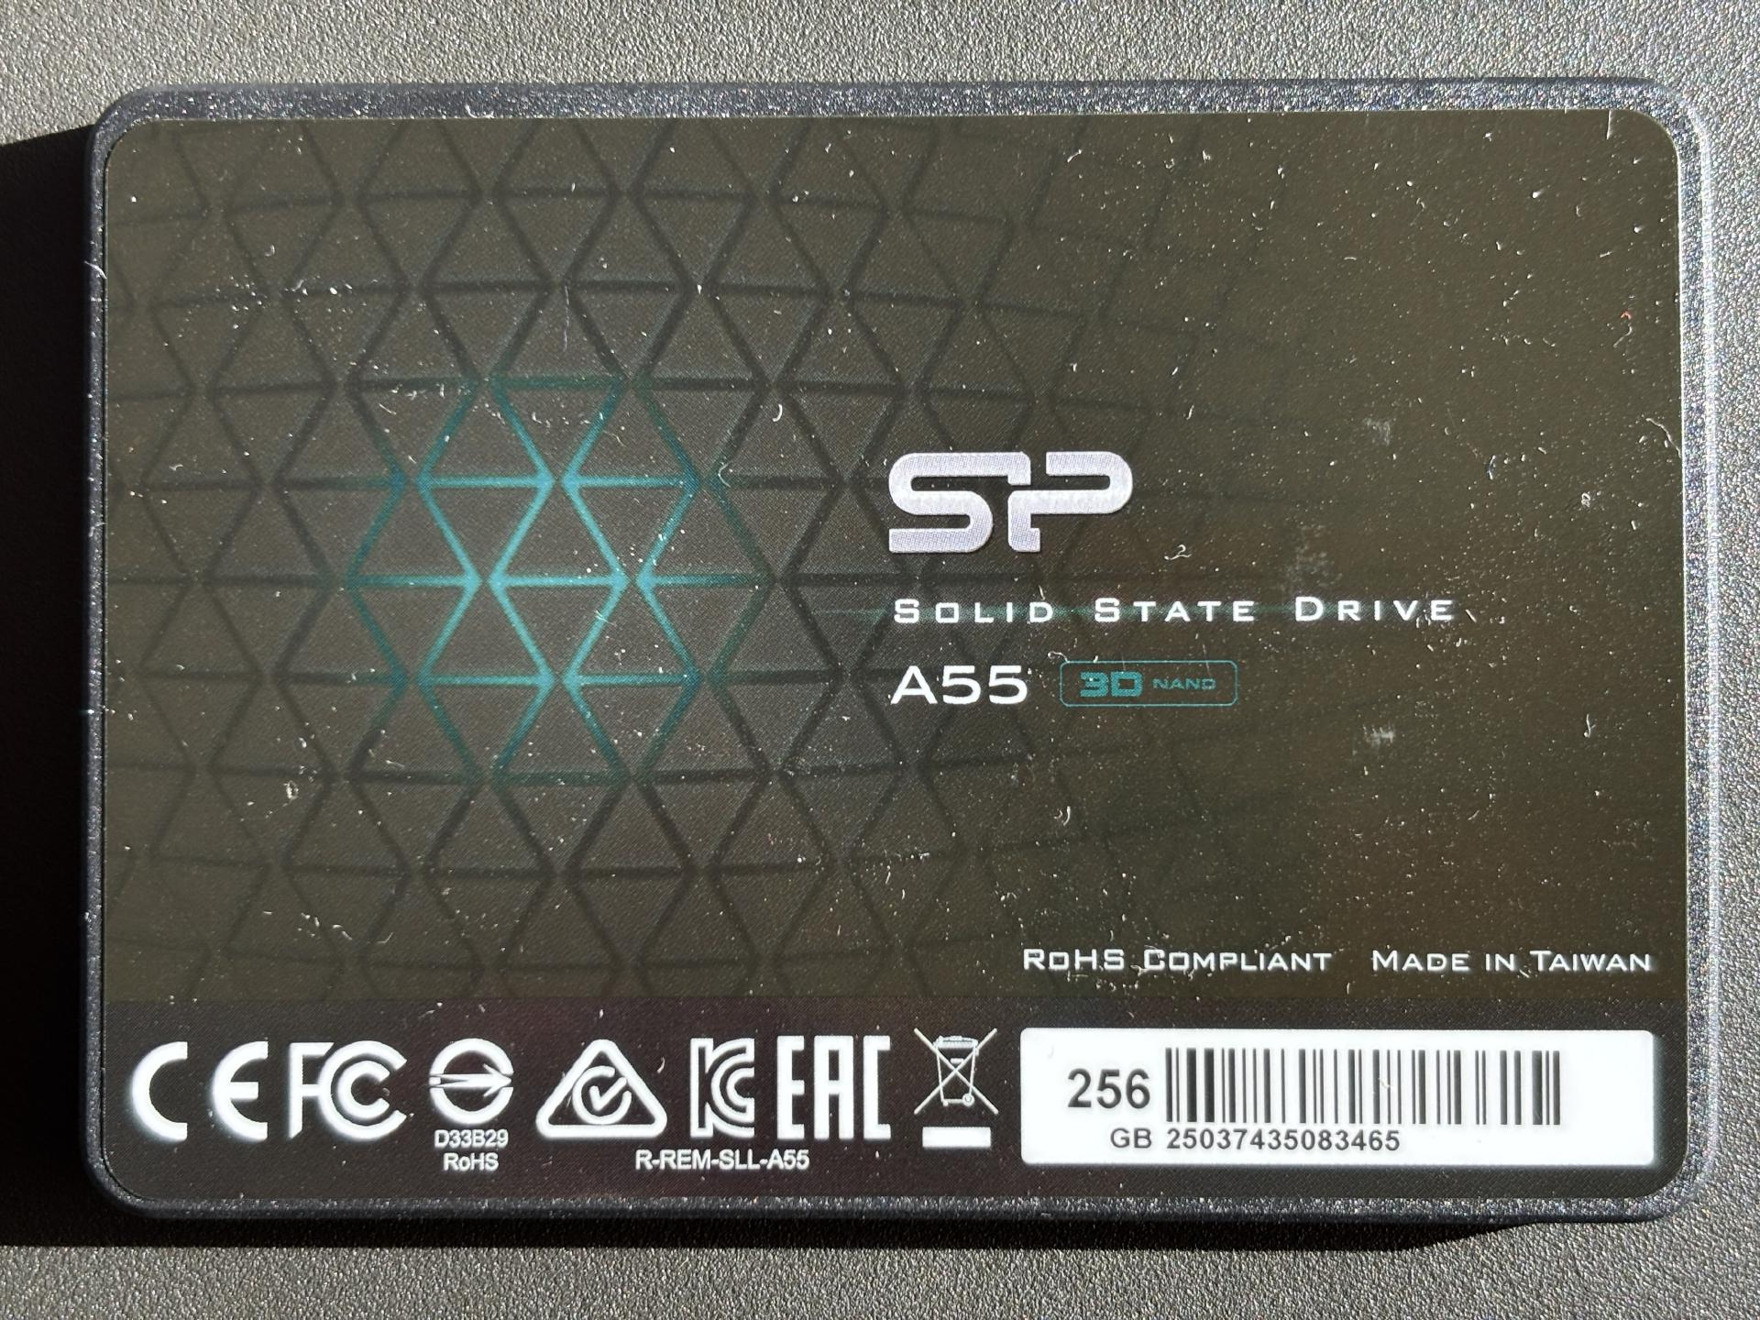
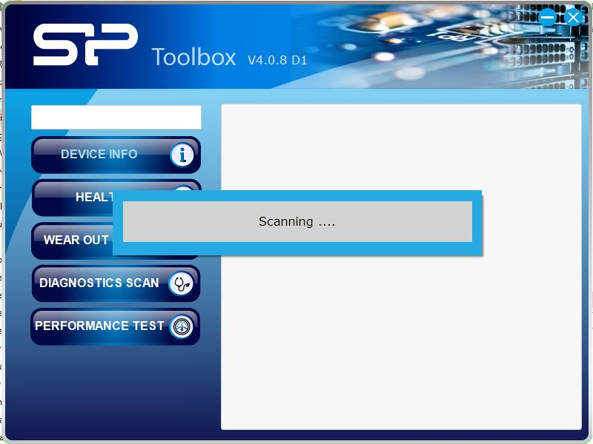

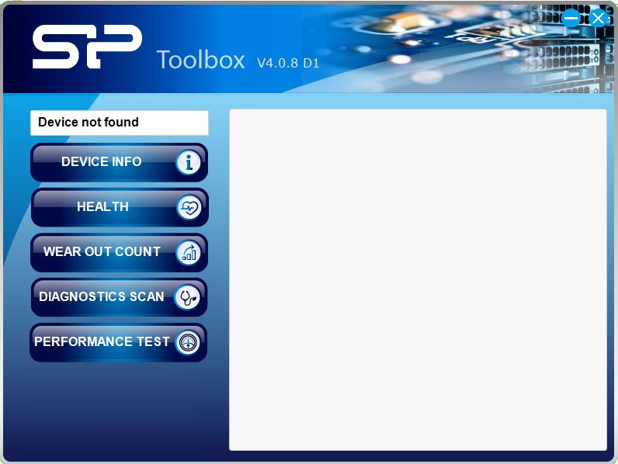

The newer version scans and find no device too. It’s the same like the older version of SP Toolbox.

