SP Toolbox on DELL notebook (Windows language German) with A55 128 GB
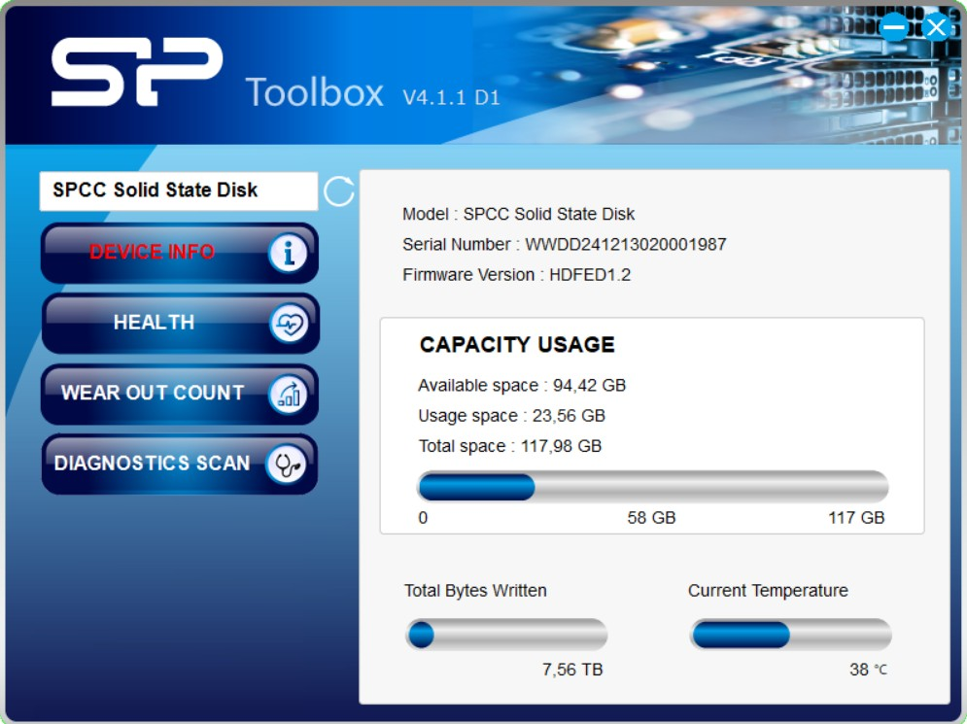
info.txt
0 C:,SPCC Solid State Disk,HDFED1.2,WWDD241213020001987

SP Toolbox on Lenovo notebook (Windows language original German and switched for additional test to English) with A55 256 GB looks like the first tests
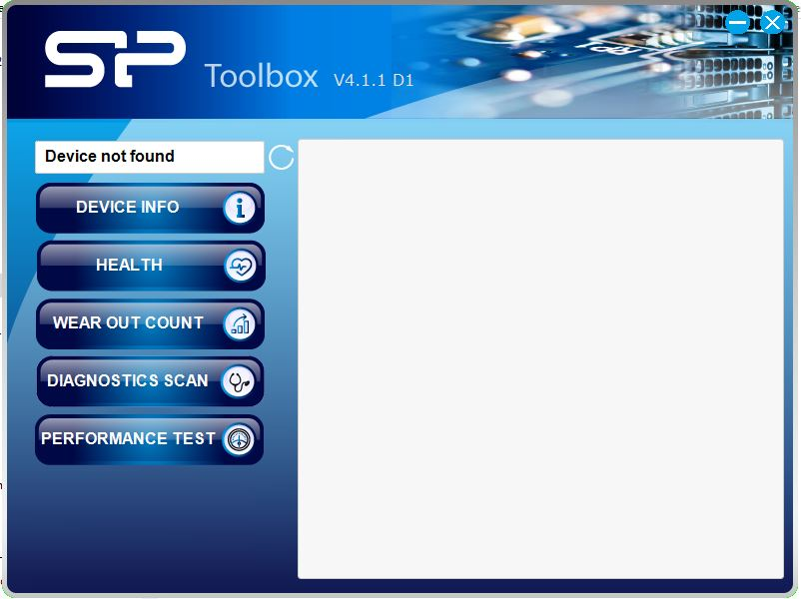
info.txt
0 C:,SPCC Solid State Disk,V1.0.4,MQ32A71704011
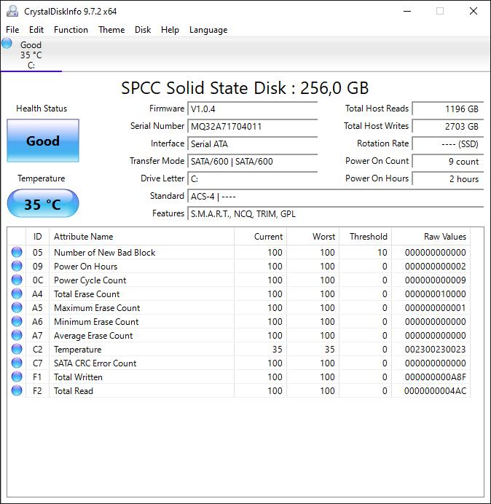
S/N and firmware version matches with CrystalDiskInfo.
SP Toolbox detect the SSD and write the infos to info.txt but says “Device not found” and cannot display these and other infos. Why? And why S/N and FW looks so different?
0 C:,SPCC Solid State Disk,HDFED1.2,WWDD241213020001987
0 C:,SPCC Solid State Disk,V1.0.4,MQ32A71704011

